Logo Steps I

Open your logo (hand drawing) that you scanned in Photoshop.
If it’s not available, re-draw it, then scan it and proceed.

Crop your final logo from the “logo handout” so you only have one logo.

Go to IMAGE SIZE and change the dimensions to less than 300 x 300 pixels and 72 dpi.

If you want to change the contrast or brightness go to IMAGE, ADJUSTMENTS, LEVELS.

Save it as a .JPG titled,”Logo-downsized” to your portfolio.

Open Macromedia FLASH, then Go to FILE, IMPORT, IMPORT TO STAGE
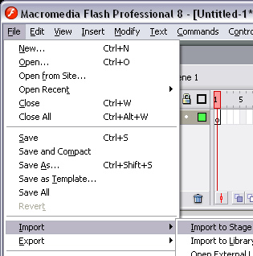 Browse for your file and double click it.

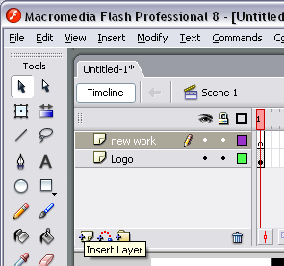
Create a new layer on top of your hand drawn logo so it’s unaffected by your new work.

Watch the 1st 5 minutes of video tutorial “Logo animation.mov”
located in the Z:”tutorials, Videos, Flash folder”.

Create a logo with the Pen tool
The Pen tool offers a way to draw precise straight or curved line segments. Click to create points on straight line segments, and drag to create points on curved line segments. You can adjust the segments by adjusting points on the line. You'll use the Line and Pen tool to create the logo.
- In the Tools panel, select the Pen tool or the Line tool.
- Click the dot next to the number 1, and then click the dot next to the number 2 to create a straight line segment.
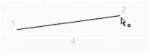
- Click the dot next to the number 3 and next to the number 4 in sequence (as though you were completing a dot-to-dot drawing). You create the straight line segments that comprise the logo.
- To close the path, position the Pen tool over the first anchor point (the dot by number 1). A small circle appears next to the pen tip when it is positioned correctly. Click to close the path. After the path is closed, it fills with the selected fill color.
By default, selected curve points appear as hollow circles, and selected corner points appear as hollow squares.
- With the Selection tool, move the pointer around the logo that you created.
When you move the pointer over a corner point, which you can drag to create various angles, the pointer appears as follows:
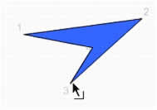When you move the pointer over a curved line segment (you don't have curve points in your logo), which you can drag to create various curved lines, the pointer appears as follows: 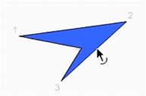

Using layers
Layers are like transparent sheets of acetate stacked on top of each other on the Stage. Layers help you organize the artwork in your document. You can draw and edit objects on one layer without affecting objects on another layer. Where there is nothing on a layer, you can see through it to the layers below.
To draw, paint, or otherwise modify a layer or folder, you select the layer in the Timeline to make it active. A pencil icon next to a layer or folder name in the Timeline indicates that the layer or folder is active. Only one layer can be active at a time (although more than one layer can be selected at a time).
When you create a new Flash document, it contains only one layer. You can add more layers to organize the artwork, animation, and other elements in your document. The number of layers you can create is limited only by your computer's memory, and layers do not increase the file size of your published SWF file. Only the objects you place into layers add to the file size. You can also hide, lock, or rearrange layers.
You can also organize and manage layers by creating layer folders and placing layers in them. You can expand or collapse layer folders in the Timeline without affecting what you see on the Stage.
For an interactive introduction to working with layers in Flash, select Help > Flash Tutorials > Basic Tasks > Work with Layers.

